**EquiFarm Project – Capacity Building Module Design**

**Screen 1 Screen 2**

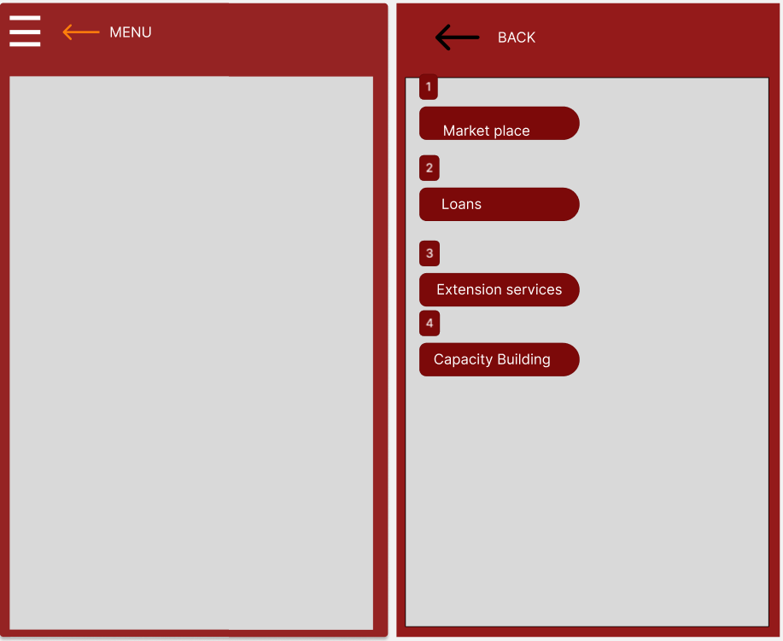

**Screen 1:** The user will be able to access the menu after logging in. From which he/she will be to navigate the application.

**Screen 2:** On clicking the menu bar the user will access the four modules; Market place, loans, Extension services and capacity building.

**Screen 2 screen 3**

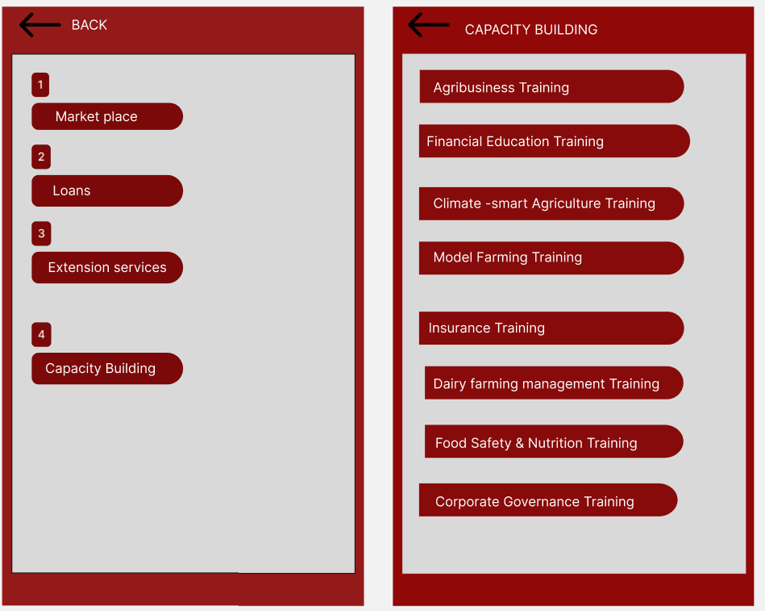

**Screen 3:** On clicking the capacity building module, the user will access the trainings components. The trainings will be provided in the form of blogs, videos or in person

**Screen 3 Screen 4**

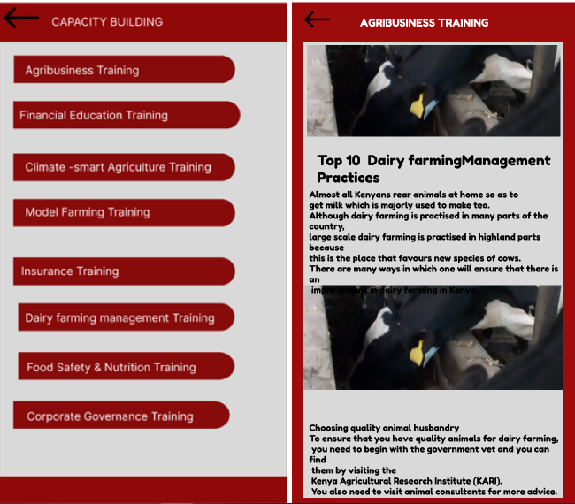

These trainings will be provided in the form of blogs, videos, animations or in person by the agricultural experts.

*Designed by: Joram Mugesa, Priscah Chelangat and Beth Mwangi*